Investment Banking Deal Pipeline Management System

Complete System Documentation (Frontend + Backend + Database)

1. Introduction
Investment banking teams handle multiple high-value deals simultaneously, each progressing through complex stages such as Prospect → Evaluation → Closure. Traditionally, many small and mid-sized investment banks rely on spreadsheets, emails, and disconnected tools to manage this process, which leads to inefficiencies, security risks, and lack of visibility.
The Investment Banking Deal Pipeline Management System is a secure, centralized, web-based application designed to address these challenges by providing structured deal tracking, role-based access control, and secure collaboration.

2. Problem Statement
Existing deal management practices suffer from the following issues:
- Deal information scattered across spreadsheets, emails, and chat tools
- Multiple versions of Excel files edited by different users
- No control over who can view sensitive financial data
- Unstructured communication and notes
- Shared spreadsheets leading to unrestricted access
These limitations increase operational risk and reduce efficiency.
3. Solution Overview
The proposed system is a secure, centralized Deal Pipeline Management Portal that:
- Centralizes all deal-related data
- Enforces role-based access (USER vs ADMIN)
- Protects sensitive financial information
- Tracks the complete deal lifecycle
- Enables structured collaboration through notes
- Scales with team and deal growth
- Meets modern security and compliance expectations

4. Technology Stack

4.1 Frontend
Layer | Technology
Framework | Angular 17
UI Library | Angular Material
State Management | Angular Services
HTTP | HttpClientModule
Forms | Reactive Forms
Routing | Angular Router
Styling | CSS / Angular Material Themes
Security | JWT Interceptor
Communication | REST API

4.2 Backend
Layer | Technology
Language | Java 17
Framework | Spring Boot
Security | Spring Security + JWT
ORM | Spring Data JPA (Hibernate)
Build Tool | Maven
Utilities | Lombok

4.3 Database
Layer | Technology
Database | MySQL
Type | Relational Database

5. Overall System Architecture
The system follows a layered client-server architecture.
CLIENT (Browser)
│
│ Angular SPA (localhost:4200)
│ - Components (Login, Deals, Admin)
│ - Services & JWT Interceptor
│
▼
SERVER (Spring Boot – localhost:8080)
- Spring Security (JWT, RBAC)
- REST Controllers
- Service Layer
- Repository Layer (JPA)
│
▼
DATABASE (MySQL – localhost:3306)
- Users
- Deals
- Notes

6. Frontend Architecture

6.1 Frontend Modules
- Auth Module: Login, JWT handling
- Deal Module: Deal listing, deal lifecycle, notes
- Admin Module: User and role management
- Shared Module: Reusable components and guards

6.2 Frontend Security
- JWT stored securely in browser storage
- HTTP Interceptor appends JWT to API requests
- Route Guards enforce role-based navigation

7. Backend Architecture
The backend follows a layered architecture:
Controller Layer → Service Layer → Repository Layer → Database

7.1 Key Backend Components
- AuthController: Authentication and JWT generation
- DealController: Deal CRUD operations
- AdminController: User and role management
- JWT Filter: Token validation
- Service Layer: Business logic and validation

8. Database Design

8.1 Users Table
Column | Description
id | Primary Key
username | Unique username
password | Encrypted password
role | USER / ADMIN

8.2 Deals Table
Column | Description
id | Primary Key
client_name | Client name
stage | Deal stage
value | Deal value

8.3 Notes Table
Column | Description
id | Primary Key
deal_id | Foreign key (Deal)
user_id | Foreign key (User)
note | Collaboration note

9. Application Flow

9.1 Login Flow
- User accesses Angular application
- Credentials are submitted to backend
- Backend validates user credentials
- JWT token is generated and returned
- Frontend stores JWT
- User is redirected to dashboard

9.2 Authorized API Access
- Frontend sends API request with JWT
- Spring Security validates token
- Role-based authorization is applied
- Data is fetched from database
- Response is returned to frontend

10. Security Flow
- Stateless JWT-based authentication
- BCrypt password encryption
- Role-based endpoint access
- Secure REST communication

11. Key Features
- Secure login and authentication
- Role-based access control (RBAC)
- Deal lifecycle management
- Structured collaboration via notes
- Centralized data management
- Scalable and maintainable architecture

12. Non-Functional Requirements
- High security for sensitive financial data
- Scalability with increasing users and deals
- Maintainability using layered architecture
- High availability and performance

13. Screenshots (Application UI)
The following screenshots demonstrate key functionalities of the Investment Banking Deal Pipeline Management System.

13.1 Login Page
- Secure login using username and password
- JWT-based authentication handled by backend
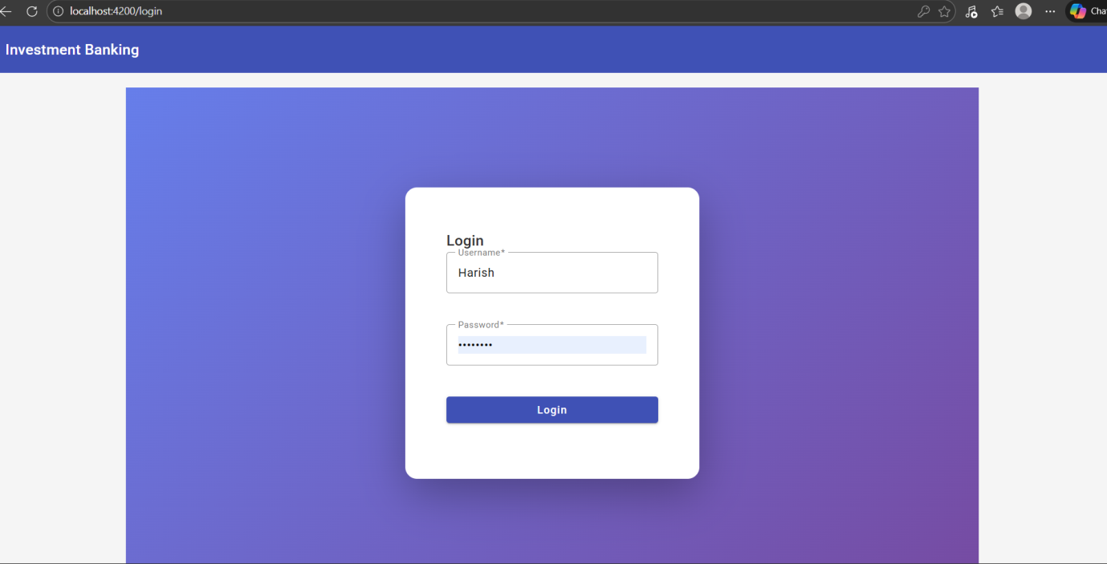

13.2 Deal Pipeline – Admin View
- View all deals across stages
- Filter by Deal Type, Sector, and Stage
- Create, Edit, View deals and add notes
- Full visibility including deal value
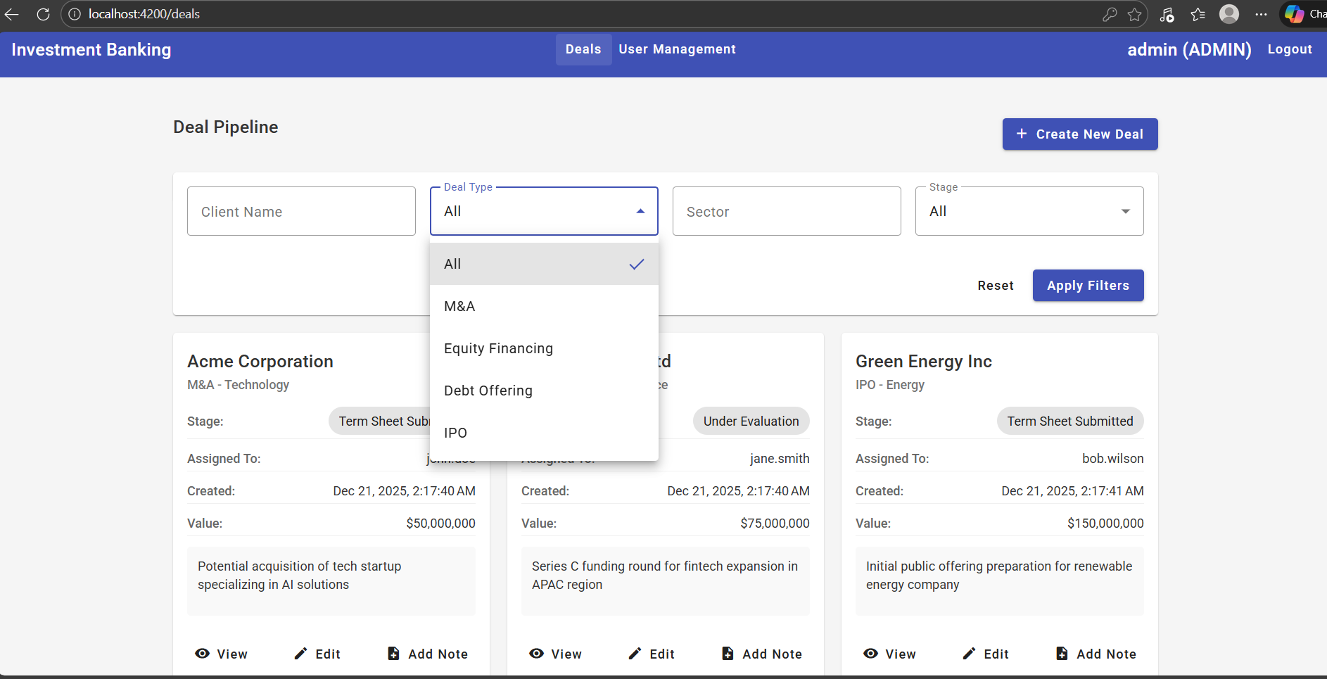

13.3 User Management – Admin Module
- Admin-only access
- Create new users
- Assign roles (ADMIN / USER)
- Activate or deactivate users
- 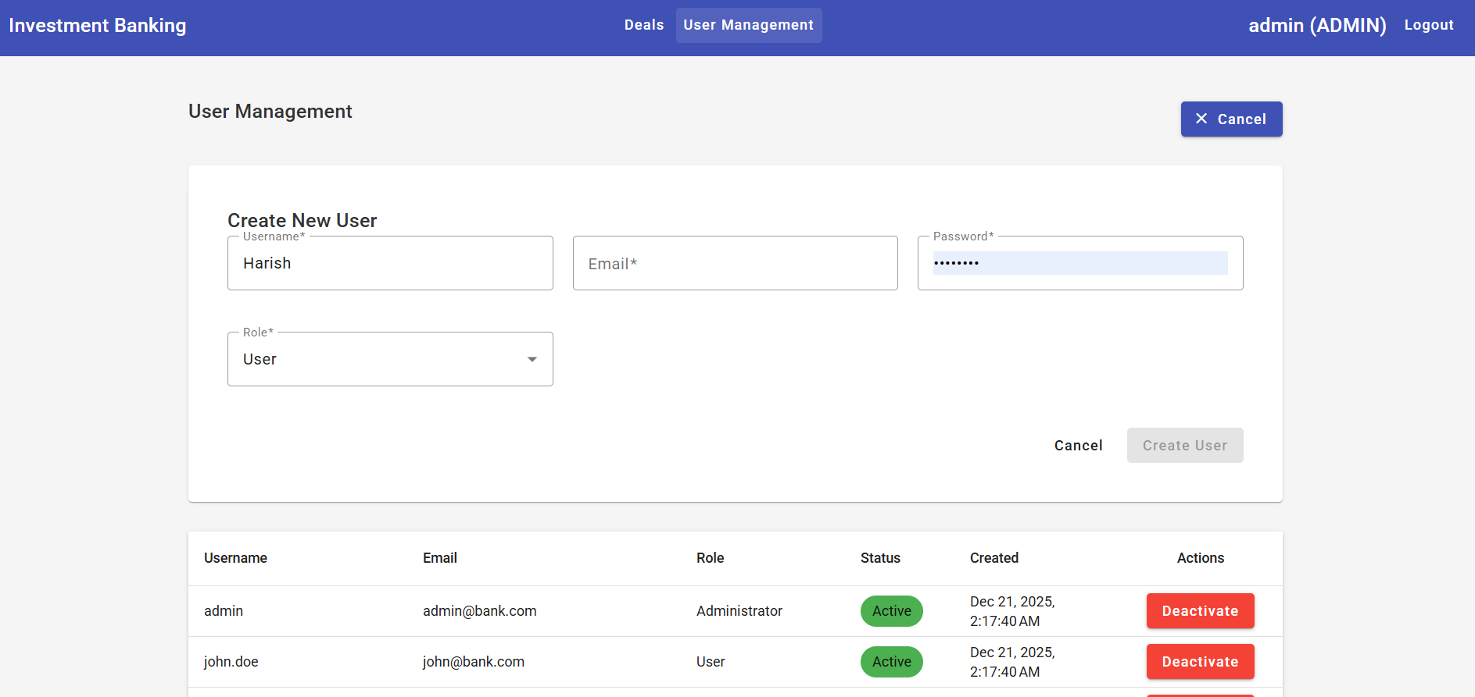

13.4 Deal Pipeline – User View
- Restricted navigation (Deals only)
- Role-based access control enforced
- Users can view and update assigned deals
- Sensitive administrative options hidden
- 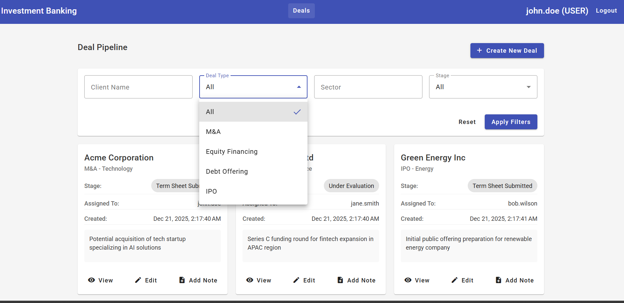

14. Conclusion
The Investment Banking Deal Pipeline Management System provides a modern, secure, and scalable solution for managing investment banking deals. By replacing spreadsheets and emails with a centralized platform, the system significantly improves data security, collaboration, and operational efficiency.
This project demonstrates real-world full-stack development using Angular, Spring Boot, JWT security, and MySQL, making it suitable for enterprise use, academic submission, and professional portfolios.

Investment Banking Deal Pipeline Management System

Submitted by:
Your Name : Harish Karanam
Git : Backend: Akhimudiraj/Investment_Banking_backendd
Frontend: Akhimudiraj/Investment_Banking_Frontendd
Mail :karanamharish2003@gmail.com

